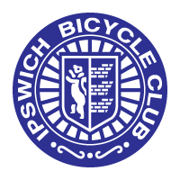

IPSWICH BICYCLE CLUB

<https://ipswichbicycleclub.co.uk/>

Open 10 Mile Time Trial

Promoted for and on behalf of Cycle Time Trials under their Rules & Regulations on

Saturday 27th May (14:00)

Crowfield Circuit (CTT Course No. B10/32) course

Officials

Timekeeping

Mr Angus Jardine and Mr Mark Salter

Marshals and helpers

Members and friends of IBC

Event Secretary

Jon Carlyon

123 Parliament Rd, IPSWICH, Suffolk, IP45EP

[carljonath@aol.com](mailto:carljonath@aol.com)

07910 802047

EVENT HQ.

Crwofield Village Hall , Crowfield, Ipswich IP6 9SZ

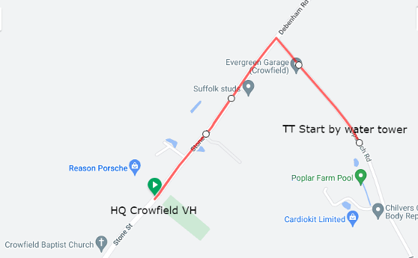

START at southernmost white post at entrance to water tower at Crowfield going towards Hemingstone. Take second left (1.8 miles), WITH CARE onto Gosbeck road and continue north through Gosbeck to junction with B1077, where bear left past Framsden Windmill to junction with A1120. Turn left and continue to Pettaugh, where turn left onto Crowfield road continue to FINISH approx. 100 yds past Rose PH, in line with yellow hydrant on opposite side of road at entrance to New Hall.

Course record: Male – Ross Fawcett (Pedal Power RT) 21:04 (2nd Jun 2018)

Female – Becky Johnson (Stowmarket & District CC) 24:12 (15th May 2018)

Regulations

Protective Helmets All competitors must wear a properly affixed helmet which must be of hard/soft shell construction. Helmets should conform to a recognised Standard such as SNELL B95, ANSI Z90.4, AUS/NZS 2063:96, DIN 33-954, CPSC or EN 1078.

Front and rear lights: Cycling Time Trials mandates that riders use a front and rear light, either flashing or constant, visible to other road users and active while the machine is in use. You will be refused a start without one.

Warming Up. No warming up along the course by competitors once the event has started.

U-Turns will not be permitted on the course or on roads adjacent to the start and finish areas whilst the race is in progress.

Note-Any breaking of this Regulation in the first case may mean disqualification from the event. Further cases will be referred to the District Committee.

Definition: A U-Turn is defined as a 180 degree turn completed within the highway whilst astride the bicycle, it is recommended that riders dismount, check the road is clear and then walk across the road.

Prizes

Scratch

1st £30, 2nd £20, 3rd £10

Vet on Standard

1st £30, 2nd £20, 3rd £10

Fastest lady £30

Team prize £10 per rider

One rider one prize (except team)